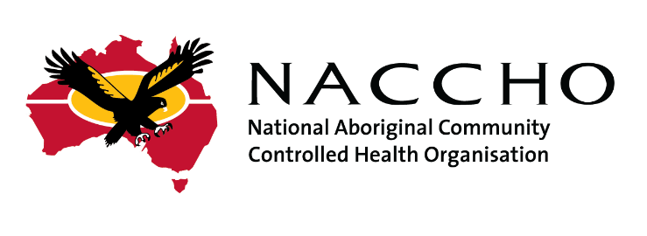
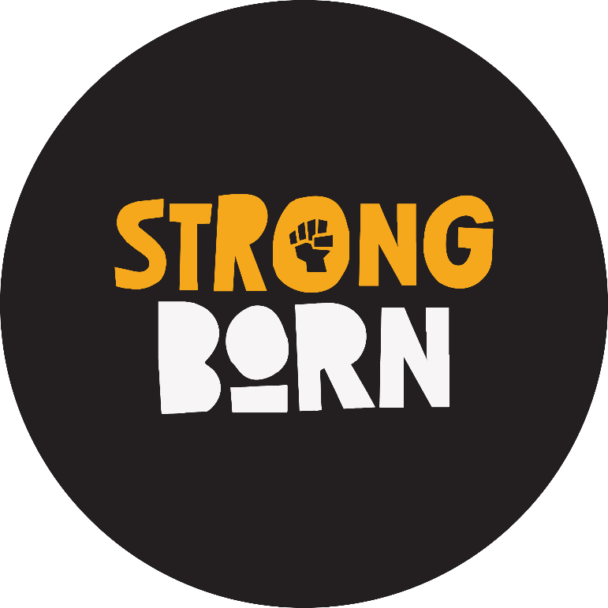

FASD Communications and Engagement Grant
Round 3
APPLICATION FORM

June 2024

FASD Communications and Engagement Grant Information
The Strong Born campaign was launched by NACCHO in 2023 following a co-design process with the National FASD Working Group, with the support of the Foundation for Alcohol Research and Education (FARE).
The Strong Born campaign includes a range of strengths-based and culturally safe materials and templates to raise awareness of and increase understanding of FASD and the harms of drinking alcohol while pregnant and breastfeeding.
A number of ACCHOs successfully delivered innovative local FASD awareness campaigns in 2023 through Grant Rounds 1 and 2.
Grant Round 3 of the Strong Born campaign is supported by the Department of Health and Aged Care and is open to all NACCHO members.
ACCHOs can apply for FASD Grant funding between $10,000 and $60,000 (GST excl) to deliver communications and engagement activities in their community or deliver a regional FASD response in collaboration with other ACCHOs and organisations.
Following feedback from previous grant rounds, ACCHOs will have an extended period of time to deliver activities - until May 2025.
Grant Round 3 is the only NACCHO FASD Grant Round available in 2024.
All ACCHOs are strongly encouraged to apply, regardless of whether they already deliver FASD-specific programs or have previously received funding under Grant Round 1 or 2.

Closing Date
Please submit applications by 23:00 Australian Eastern Standard Time (AEST) Friday 19 July 2024
If you would like to request a time extension to submit your application, please email fasdprograms@naccho.org.au

Application Help
All parts of this application must be completed. More information about this funding can be found at: www.naccho.org.au/fasd/grant
For any questions relating the FASD Grant or the application process, please reach out to the NACCHO FASD Grants team at fasdprograms@naccho.org.au

How much FASD Grant funding can I apply for?
ACCHOs with active client numbers of 1 to 3,500 people per annum may apply for up to $40,000 (excl GST) in grant funding.
ACCHOs with active client numbers of 3,501 or more per annum may apply for up to $60,000 (excl GST) in grant funding.
Eligible ACCHOs should indicate the specific funding amount they are applying for in the Application Form. If your annual client numbers are less than 3,500, please ensure the total funding requested does not exceed $40,000 (excl. GST). Please reach out to fasdprograms@naccho.org.au if you have questions about this guideline or would like to apply for an exception to this threshold.
Please note:
- Only one application per organisation can be submitted.
- Funding can be used on more than one eligible activity.
- Funding cannot be used on ineligible activities.

Eligible Activities
Eligible Activities are broad in nature and will vary between organisations. Eligible activities may include one or more of the following:
- Creation of strengths-based locally relevant communications materials and resources by utilising existing ‘Strong Born’ campaign materials, or adapting the Strong Born strengths-based messages, to raise awareness of FASD and the harms of drinking alcohol while pregnant and breastfeeding.
- Hosting FASD community events, camps and/or yarning circles.
- Running FASD information and/or training sessions for staff and community members.
- Promoting the Strong Born campaign on multimedia platforms, such as TV, radio, billboards or social media.
- Translation or adaptation of ‘Strong Born’ campaign materials and/or key messages into Aboriginal and Torres Strait Islander languages.
- Production of additional copies of the ‘Strong Born’ campaign materials.
- Running FASD training and awareness workshops for clinicians, ACCHO staff and/or community.
Examples of activities delivered in previous rounds include:
- Creating your own Strong Born posters or free merchandise (such as mugs, polos, calendars etc) featuring local artwork or local mums, bubs and/or families using the customisable Strong Born poster templates provided.
- Community engagement events, such as a BBQ or Strong Born Buy Swap Sell market, and Strong Born camps.
- Advertise the Strong Born campaign on billboards, local TV or radio.
- Translating the Strong Born community booklets/animations into local languages.
- Printing additional localised merchandise and booklets
For more details, please refer to the Grant Round 3 Funding Guidelines and Grant Activity Support Kit.

Part A
Organisation and Contact Details
Organisation Name: | Click or tap here to enter text.
ABN: | Click or tap here to enter text.
Address: | Click or tap here to enter text.
Contact Person: | Click or tap here to enter text.
Contact Email: | Click or tap here to enter text.
Contact Phone: | Click or tap here to enter text.
Secondary Contact Person: | Click or tap here to enter text.
Contact Email: | Click or tap here to enter text.
Contact Phone: | Click or tap here to enter text.

If you are applying on behalf of a consortium or collaboration of ACCHOs, please provide details of a contact person at each organisation involved:
Additional Organisation and Contact Details
Organisation Name: | Click or tap here to enter text.
Contact Person: | Click or tap here to enter text.
Contact Email: | Click or tap here to enter text.
Organisation Name: | Click or tap here to enter text.
Contact Person: | Click or tap here to enter text.
Contact Email: | Click or tap here to enter text.
Organisation Name: | Click or tap here to enter text.
Contact Person: | Click or tap here to enter text.
Contact Email: | Click or tap here to enter text.

Part B
All questions must be answered.
Eligibility

Q1. Is your organisation an Aboriginal Community Controlled Health Organisation (ACCHO) and NACCHO member? | ☐YES
Q2. What is your organisation’s MM rating? | ________
Q3. On average, how many clients does your organisation serve per year? | ________
Q4. How much FASD Grant funding are you applying for?
Client numbers of 1 to 3,500 may apply for up to $40,000
Client numbers 3,501 or more may apply for up to $60,000

Part C
All questions must be answered.
Grant Activities

Q1. Which of the below categories best describes the type of activities planned under the FASD grant (Please tick all that apply)  - Disseminating and promoting the existing Strong Born campaign materials.  - Adapting Strong Born material to localise content.  - Creating and disseminating materials with translations of Strong Born campaign materials or campaign key messages into Aboriginal and Torres Strait Islander languages.  - Delivering engagement activities such as community events, camps and yarning circles.  - Running FASD training and awareness workshops.  - Other innovative FASD health promotion activities and/or community development activities. | ☐YES  ☐YES  ☐YES  ☐YES  ☐YES  ☐YES
Q2. Briefly describe the activities your organisation will deliver. Please include an indicative budget breakdown showing what the grant funding will be used for.

Please include details on what costs will be covered, who will be the target audience, when the activities will occur and the impact you expect to see as a result of planned activities.
Please ensure responses are less than 350 words.

Click or tap here to enter text.

Part D
All questions must be answered.
Capacity to deliver activities
Q1. Outline the staff, resources, experience and/or partnerships your organisation will draw on to design and deliver planned grant activities:
Click or tap here to enter text.

Q2. Please describe the level of community awareness and interest in FASD and how your planned activities will support Strong Born babies and strong families.
Click or tap here to enter text.

Part E
Signed for and on behalf of Click or tap here to enter text., in accordance with its rules, and who warrants that he/she is authorised to sign this Agreement:

Click or tap here to enter text.
(Name and position held by Signatory) |  | (Signature)
 |  | Date:

